IE4-MC Lab Session #1: Preparation sheet
Surname, First Name | Group Team
1. Adriana Bostandzhieva  2. Nikolai Stoitsov  3. | 1 ◻ A B C D E F  2 ◻  3 ◻
This preparation sheet must be filled and uploaded to EMIL by every student before the lab session. Cooperation within the lab team (of 2-3 students) is possible (same solution). However, no cooperation across lab teams.

Question 1 (3 POINTS)
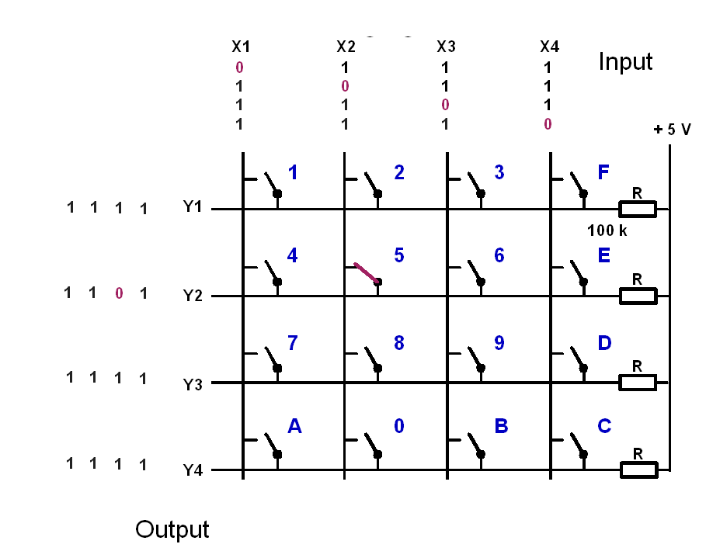
key | y1 | y2 | y3 | y4
1 pressed | high | high | high | High
5 pressed | high | Low | High | high
9 pressed | High | High | High | High
C pressed | High | High | High | High
0 pressed | High | Low | High | High
0 and 5 pressed | High | Low | High | Low

Let the input signals to the keyboard be (X1,X2,X3,X4)=(1,0,1,1). Give the output signals (Y1,Y2,Y3,Y4), if the following keys are pressed:

Question 2 (5 POINTS)
The basic operation of the keyboard decoder is as follows:
- Apply a voltage pattern at the inputs of the keyboard (X1,X2,X3,X4) that sets one column 0 (low) and the others 1 (high).
- Wait to compensate for propagation delays.
- Read the output pattern (Y1,Y2,Y3,Y4) and decide based on (Y1,Y2,Y3,Y4) and the knowledge which column has been set 0 (low), which key has been pressed and print the key.
- Cycle the column with the zero and continue with 1.
- The function shall be non-blocking, so it must not wait if no key is pressed but leave the function and reenter it to check again.
- Solutions with more than 50 instructions are not accepted (number of semicolons or pairs of curly braces)
Draw the Nassi-Shneiderman-Diagram of the program (with structurizer tool: http://structorizer.fisch.lu/ ):
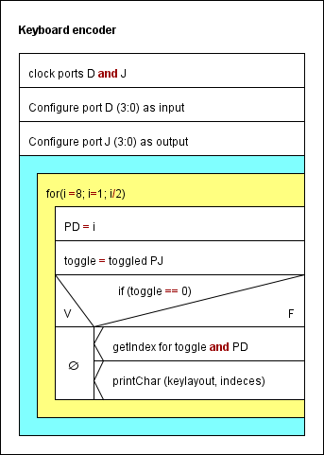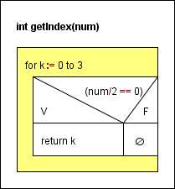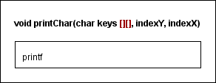

Question 3 (3 points)
Write the source code in C (shall be syntax error free (tested!), further tests with real-time constraints can be done in the lab session):
#include "lm3s9b92.h"
#include <stdio.h>

void printChar( char keys[4][4], int y, int x);
int getIndex(int num);

int main() {

unsigned char enableCheck;

char keylayout [4][4] = { {'1', '2', '3', 'F'},
{'4', '5', '6', 'E'},
{'7', '8', '9', 'D'},
{'A', '0', 'B', 'C'}};
int i, toggle=0;

SYSCTL_RCGC2_R = (1<<3) | (1<<8);

enableCheck = 0;

GPIO_PORTD_DEN_R |= 0x0F; // PD (3:0) enabled
GPIO_PORTD_DIR_R |= 0x0F; // PD (3:0) output

GPIO_PORTJ_DEN_R |= 0x0F; // PJ (3:0) enabled
GPIO_PORTJ_DIR_R &= 0x00; // PJ (3:0) input

GPIO_PORTD_DATA_R = 1;

while (1){
i = 8;
while (i>=1){
GPIO_PORTD_DATA_R = i; //set the value 8,4,2,1
toggle ^= GPIO_PORTJ_DATA_R; //toggle the bits of the input for easier manipulation (negative logic equivalent)
if (toggle == 0 //if all the bits are 0, nothing is pressed
continue;
else
{
printChar(keylayout, getIndex(toggle), getIndex(GPIO_PORTD_DATA_R)); //if sth is pressed, calls a print function
}//getIndex() determines the coordinates of the letter to be printed
i /= 2;
}
}
}
void printChar( char keys [4][4], int y, int x){
printf("%c", keys [y][x]);
}

int getIndex(int num){
int k;
for (k = 0; k < 4; k++){ //uses the negative logic and power of 2 properties to determine

num /= 2;
if (num == 1) //the value of the indeces
return k;
}
return num;}

